**Project Design Phase-II**

# Technology Stack (Architecture & Stack)

|  |  |
| --- | --- |
| Date | 26 October 2022 |
| Team ID | PNT2022TMID41928 |
| Project Name | Real-Time River Water Quality Monitoring and Control System |
| Maximum Marks | 4 Marks |

# Technical Architecture:

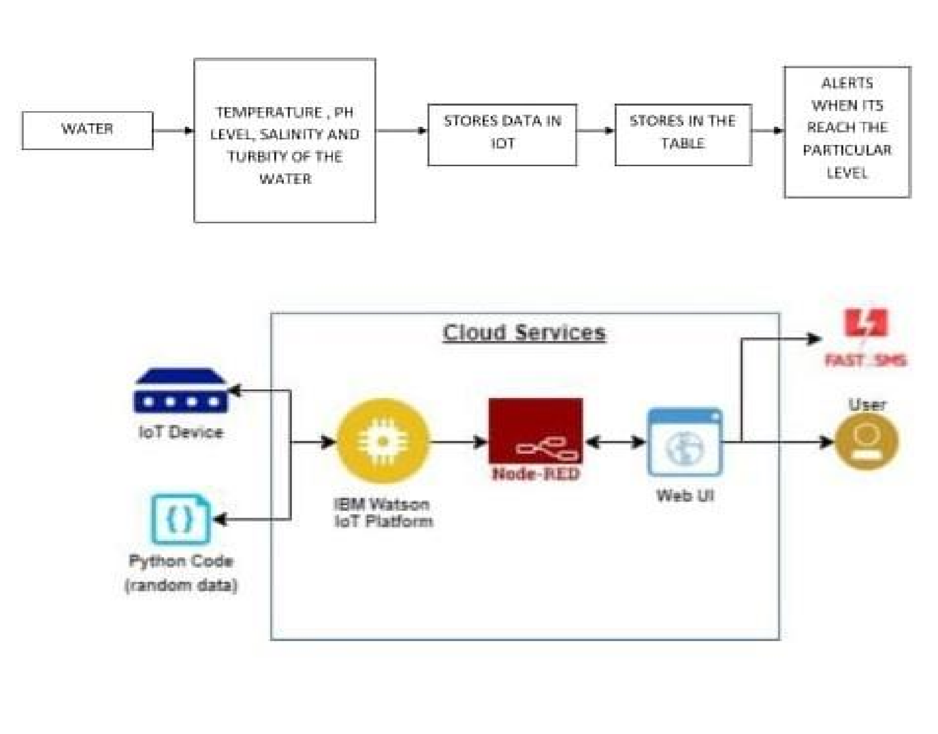

**Table-1 : Components & Technologies:**

|  |  |  |  |  |
| --- | --- | --- | --- | --- |
| **S.No** | **Component** | **Description** | | **Technology** |
| 1. | User Interface | Mobile UI | | HTML, CSS,  java script |
| 2. | Application Logic-  1(mobile application) | Machine learning model is used for identifying the quality of water | | Python |
| 3. | Database | Data Type | | NOSQL. |
| 4. | Cloud Database | Database Service on Cloud | | IBM Cloudant |
| 5. | File Storage | File storage requirements: Platform Version 4.6 | Container | IBM Block Storage |
|
| 6. | External API-1 | The data is used to compare the values for sensor with database | | IBM water quality API |
| 7. | Machine Learning Model(node-red) | For interfacing hardware and software application(a virtual  wiring tool) | | Platform: Node.js |
| 8. | Infrastructure (Server / Cloud) | Application Deployment on cloud  Cloud Server Configuration : application- client-end | | IBM cloud |

# Table-2 : Application Characteristics:

|  |  |  |  |
| --- | --- | --- | --- |
| **S.No** | **Characteristics** | **Description** | **Technology** |
| 1. | Open-Source Frameworks | App development and Machine learning model development | Python Script |
| 2. | Security  Implementations | IBM cloud service  IBM Watson IoT Platform and Device Node-Red Service | e.g. SHA-256,  Encryptions, IAM  Controls, OWASP etc. |
| 3. | Scalable  Architecture | As the proposed system involves only three sensors, the application can be easily developed into many numbers | IoT |
| 4. | Availability | Maximum down time will be about 4 hours | IoT |
| 5. | Performance | Load time for user interface screen shall not be more than 2 seconds.  Login info verified within 10 seconds. | IoT |